1

**Before you collaborate**

A little bit of preparation goes a long way with this session. Here’s what you need to do to get going.

**10 minutes**

problem statement

some of the jobseekers have a knowledge to a work otherwise don't have a knowledge about work because they did not complete a extra course.

# After you collaborate

### 4 You can export the mural as an image or pdf

prioritize

to share with members of your company who

### might find it helpful.

**2**

3

make a practical exam for separating a knowledge candidates if they have a high core then we will online interview after the candidate pass the online interview then they go for the live interview.

group idea

**TIP**

Add customizable tags to sticky notes to make it easier to find, browse, organize, and categorize important ideas as themes within your mural.

Brainstorm

##### samyappan

**A Team gathering**

Define who should participate in the session and send an invite. Share relevant information or pre-work ahead.

**Brainstorm**

**& idea prioritization**

Use this template in your own brainstorming sessions so your team can unleash their imagination and start shaping concepts even if you're not sitting in the same room.

**PROBLEM**

**How might we [your problem statement]?**

**varunkumar**

**Quick add-ons**

##### Share the mural

recommend the sutitable course for the failure student

identify the skills and select suitable course for the candidates

make basic online interview for the passed canditate

make a pratical exam to check canditate knowledge

|  |  |  |  |  |  |
| --- | --- | --- | --- | --- | --- |
|  | | | | | |
|  |  |  |  |  |  |
|  |  |  |  |  |
|  |  |  |  |  |
|  |  |  |  |  |
|  | **TIP**  Participants can use th cursors to point at whe sticky notes should go the grid. The facilitato confirm the spot by us the laser pointer holdi **H key** on the keyboard | eir re on  r can ing  ng the  . |  | make a pratical exam to check |
|  |  |  |  | canditate  knowledge |

**Share a view link** to the mural with stakeholders to keep them in the loop about the outcomes of the session.

##### Export the mural

**B Set the goal**

Think about the problem you'll be focusing on solving in the brainstorming session.

Export a copy of the mural as a PNG or PDF to attach to emails, include in slides, or save in your drive.

**C Learn how to use the facilitation tools**

Use the Facilitation Superpowers to run a happy and productive session.

[**Open article**](https://support.mural.co/en/articles/2113740-facilitation-superpowers)

make a technical online exam to check the skills and select the job

make a secondary exam for the failure student

**10 minutes** to prepare

**1 hour** to collaborate

**2-8 people** recommended

## Key rules of brainstorming

To run an smooth and productive session

##### murugan

**naveen**

To prepare a difficult questions and select to verify job needs

make a practical exam to check qualification job needs

select technical knowledge candidates the job requirenment

## Keep moving forward

##### Strategy blueprint

Define the components of a new idea or strategy.

##### [Open the template](https://app.mural.co/template/e95f612a-f72a-4772-bc48-545aaa04e0c9/984865a6-0a96-4472-a48d-47639307b3ca)

**Customer experience journey map**

Stay in topic. Defer judgment.

Encourage wild ideas. Listen to others.

recommend

the suitable

identify practical knowledge

and select the persons to get a job

make basics interviews for the passed candidates

#### courses for

the passed

candidates

## Importance

If each of these

Understand customer needs, motivations, and obstacles for an experience.

##### [Open the template](https://app.mural.co/template/b7114010-3a67-4d63-a51d-6f2cedc9633f/c1b465ab-57af-4624-8faf-ebb312edc0eb)

Go for volume. If possible, be visual.

[**Share template feedback**](https://muralco.typeform.com/to/CiqaHVat?typeform-source=app.mural.co)

tasks could get

done without any difficulty or cost, which would have the most positive impact?

## Feasibility

Regardless of their importance, which tasks are more feasible than others? (Cost, time, effort, complexity, etc.)

##### Strengths, weaknesses, opportunities & threats

Identify strengths, weaknesses, opportunities, and threats (SWOT) to develop a plan.

|  |  |
| --- | --- |
|  |  |
|  |  |

##### [Open the template](https://app.mural.co/template/6a062671-89ee-4b76-9409-2603d8b098be/ca270343-1d54-4952-9d8c-fbc303ffd0f2)

[**Share template feedback**](https://muralco.typeform.com/to/CiqaHVat?typeform-source=app.mural.co)

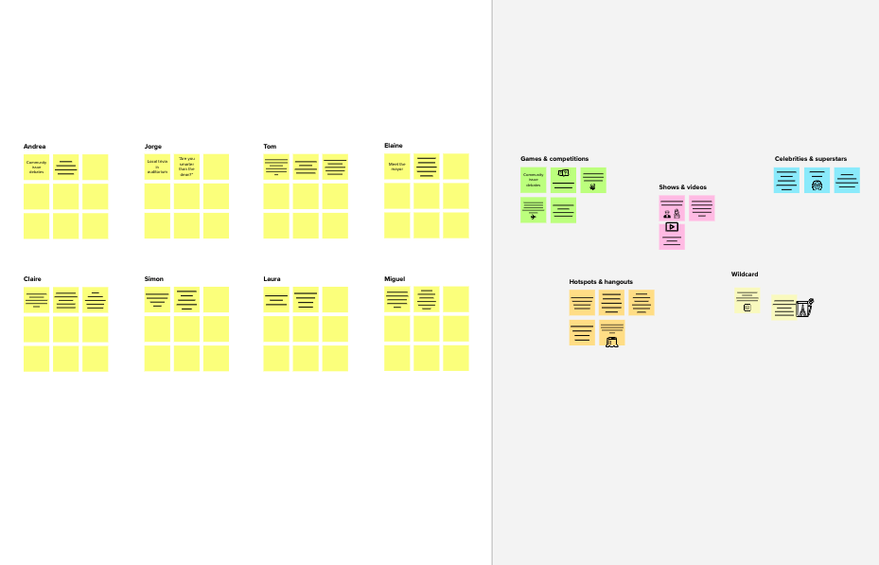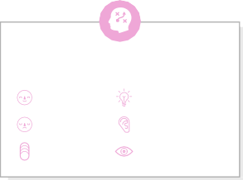

**Template**

**Need some inspiration?**

See a finished version of this template to kickstart your work.

[**Open example**](https://app.mural.co/template/e5a93b7b-49f2-48c9-afd7-a635d860eba6/93f1b98d-b2d2-4695-8e85-7e9c0d2fd9b9)